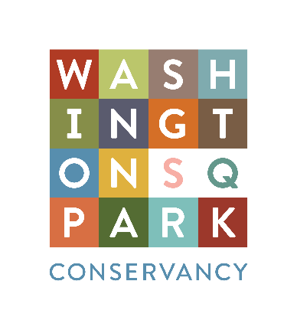
Washington Square Park Conservancy
Greeter-Guide Program
Volunteer Application
Due: March 1, 2017

About the Program
The Washington Square Park Conservancy (WSPC) is a 501(c)3 not for profit organization working with the New York City Parks Department and neighborhood groups to ensure that Washington Square Park continues as a diverse and historical urban green space through engaging volunteers and raising funds to help keep the park clean, safe and beautiful.

WSPC is accepting new volunteers into its Greeter-Tour Program, a program that interacts with Park users, helping them learn about the exciting horticulture, history, events, and culture that the Park has to offer. From our resident hawks to the coveted Arch, the Park has many stories to be told!

Volunteer Greeter-Guide Description
WSPC is seeking committed volunteers to donate their time and expertise for this free Park program. The WSPC Greeter-Tour Program provides an opportunity for interested volunteers to become an official Washington Square Park Docent.

This program runs during the warmer months. Docents will be expected to work a minimum of 2 shifts per month, and each shift will last 3 hours (totaling 6 hours per month). Shifts will be on Saturdays and Sundays from 10am to 1pm. Greeters will provide information about the Park and the Conservancy to visitors during their shift. Volunteers will work with a team of their fellow volunteers. Once docents have completed the greeter orientation program, they can continue their training to become a WSP tour guide.

Volunteers must attend and participate in the program’s orientation, as well as complete required reading on the history of the Park. Orientation sessions include lectures, workshops, and on-site tours. Training takes place on Saturdays, March 11, 18, 25. By the end of orientation, each docent will be prepared to answer all matter of questions from park visitors.

Requirements
Applicants should be:
- Comfortable speaking in groups / with the public
- Able to attend and participate in orientation sessions
- Willing and able to work two weekend shifts (three hours each) per month and meet the time commitment
- Able to help the team set up (able to lift at least 10 lbs)
- A positive representative of the Park and the Conservancy
- 18 years or older
No prior greeting-guide experience is necessary.
No fees or payments will be made, this is a volunteer role.

Important Dates
Visit washingtonsquareparkconservancy.org/volunteer for upcoming informational sessions.
March 1 - Application Due

Application Process
Applications will be reviewed the week of March 1st. Candidates selected will be notified not later than March 6th. Applicants selected to participate in the orientation program will be asked to re-commit to the program prior to orientation completion.

Please reach out to volunteer@washingtonsquareparkconservancy.org with your questions and/or if you would like to attend an information webinar.

This application is due on or before 11:59 PM March 1. Email your application to volunteer@washingtonsquareparkconservancy.org. No late applications will be accepted.

Please complete the questions below. The application should total no more than six pages when complete. This document can be saved to your computer and emailed as an attachment or copied and pasted into an email.

Contact Information
Name:

Address:

Email:

Phone (please indicate home or mobile):

How did you hear about this program?:

Please provide contact information for one reference.

Name:

Email:

Phone:

Please submit answers to the following questions, in no more than 250 words per question.

- What is your favorite place to hang out in Washington Square Park? Why?

- If you had to explain the Park to someone who had never visited, how would you convey its importance in the City?

- Why would you make a good greeter?

- What experience do you have that aligns with this program?

- What led you to apply for this volunteer program?

- Do you have any concerns or issues with the time commitment and/or workload outlined in the position description we should know?

